Fast Transient Sensors - Coursework 2
Question 1
a)
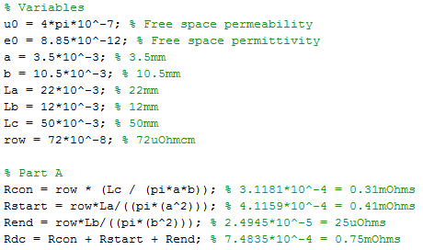
Answer: 0.75mΩ
b)
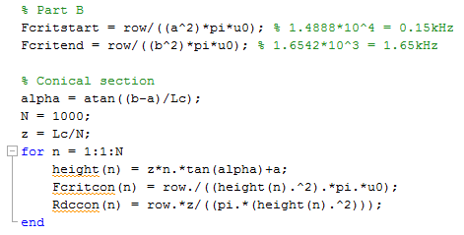
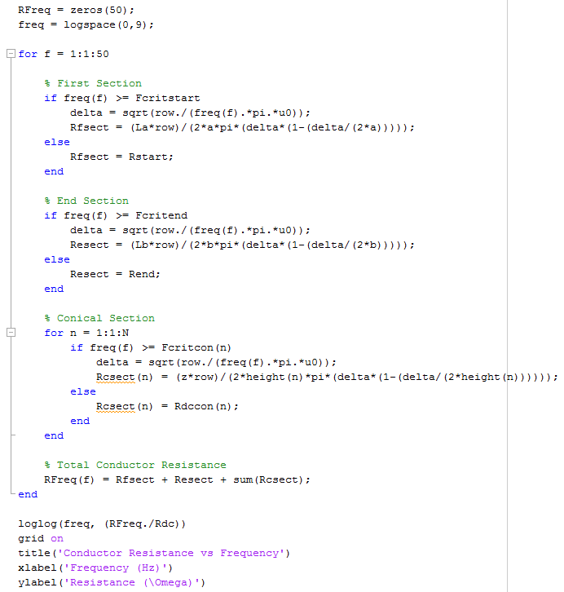
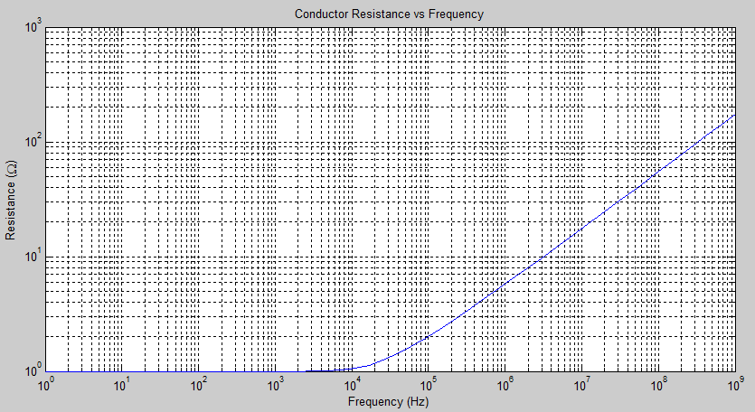
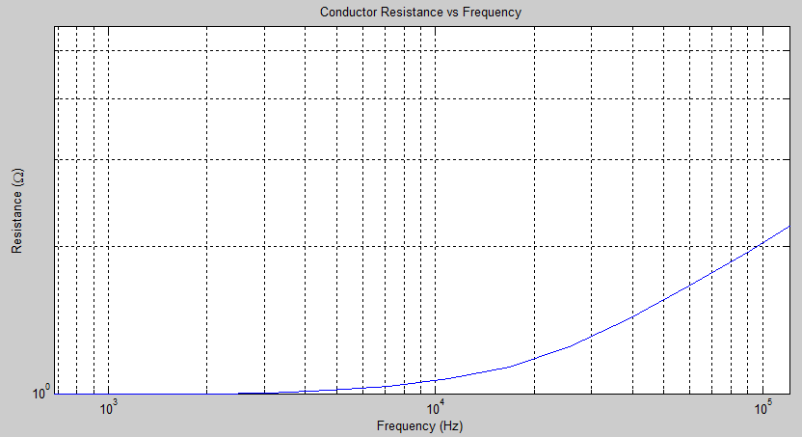
Question 2
a)
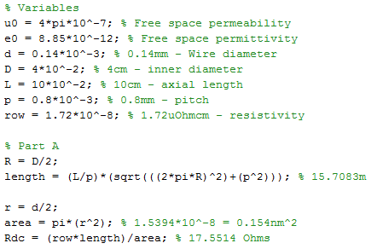
Answer: 17.55Ω
b)
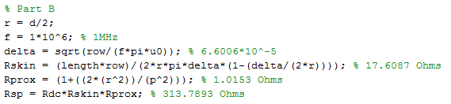
Answer: 313.79Ω
c)
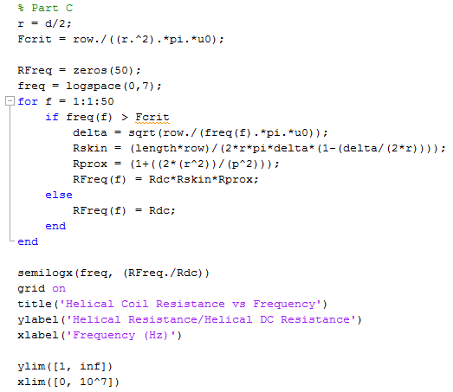
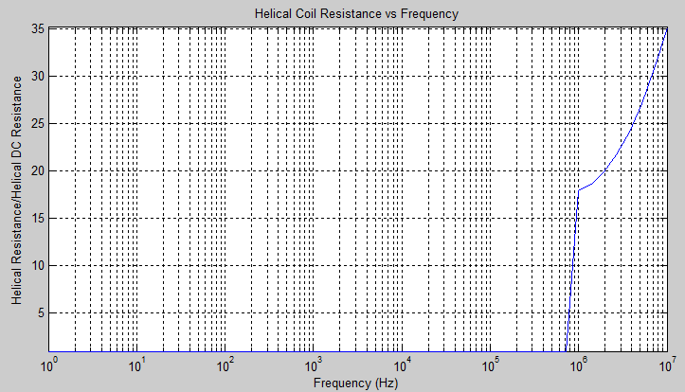
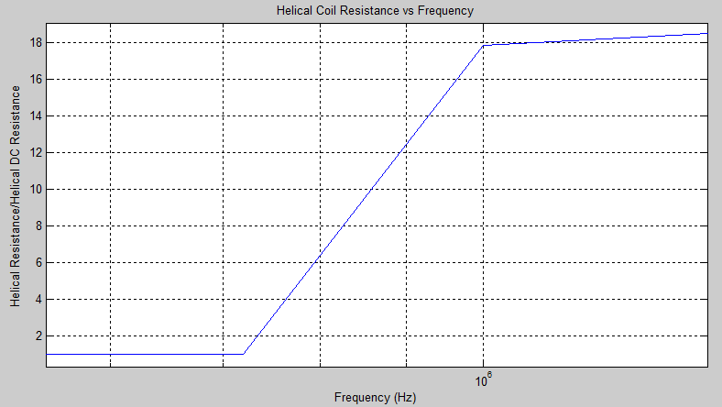
d)
Answer: Litz wire is used to maintain coil resistance up to high frequencies (1MHz) with affecting the inductance. The Litz wire consists of many thin, insulated wire strands which are twisted together are proportional to the overall length of the wire. Due to each thin wire having a thickness less than the skin-depth, there is a reduced amount of skin and proximity effect losses. The Litz wire is commonly used in high speed motors, inductors and transformers.
Question 3
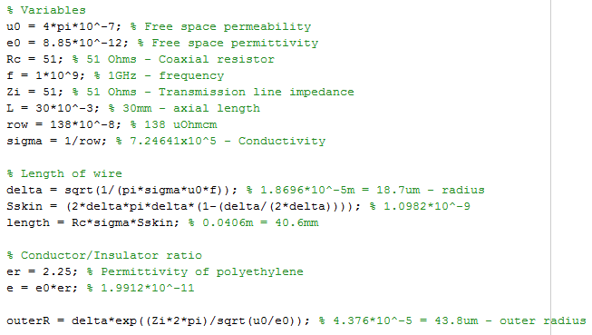
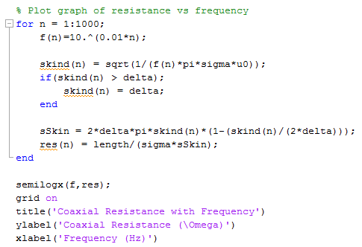
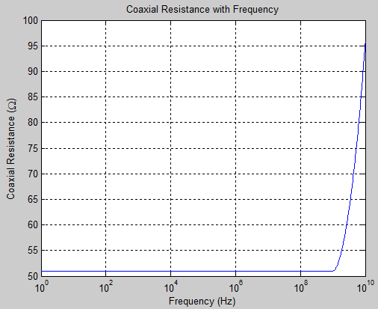
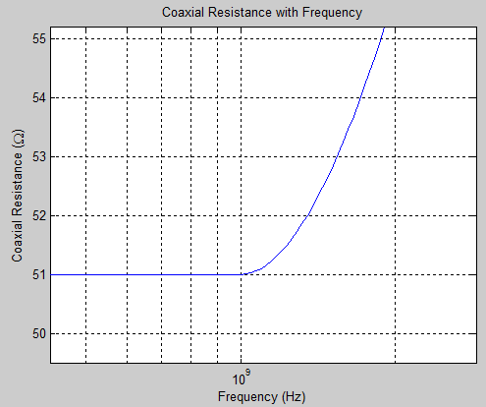
Answer: Although the wire has a length of 40.6mm, if you implement the insulated resistor to be in a square wave form with width of 2mm and length of 3mm, the entire length of the wire will fit within the 30mm axial length, for example:
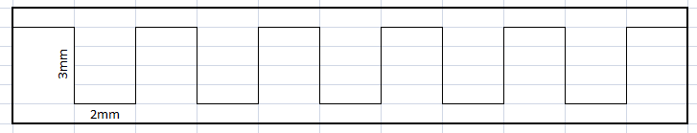
Question 4
a)
See appendix.
b)
See appendix.
c)
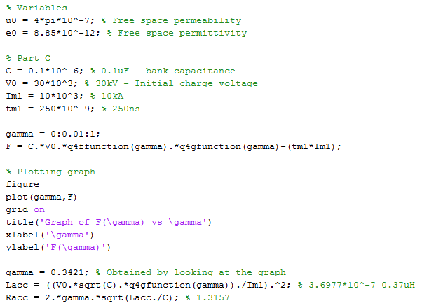
Where q4ffunction and q4gfunction are:
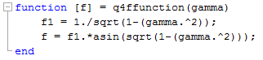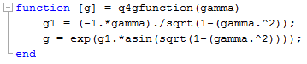
Graph used to obtain gamma:
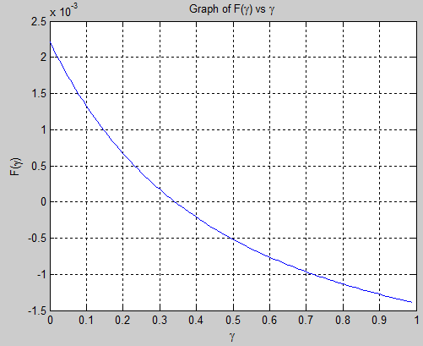
Answers: Accurate inductance (L) = 0.37µH and Accurate resistance (R) = 1.32Ω
d)
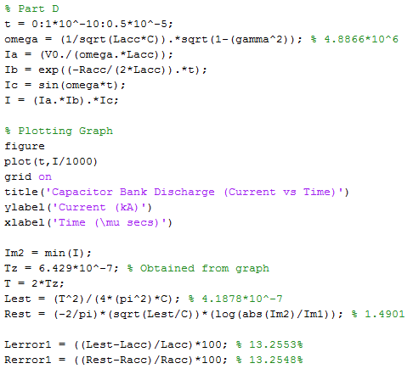
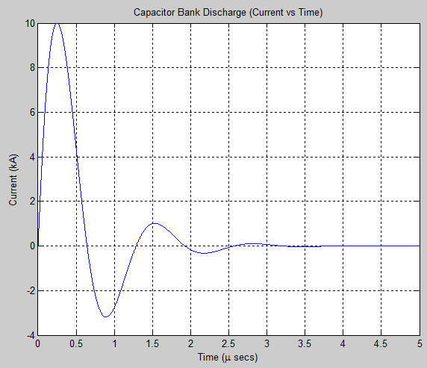
Answers: Estimated inductance (L) = 0.42µH, estimated resistance (R) = 1.49Ω, inductance error = 13.26% and resistance error = 13.26%.
e)
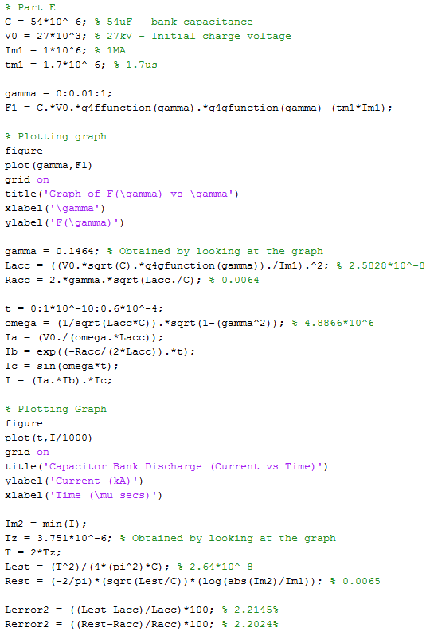
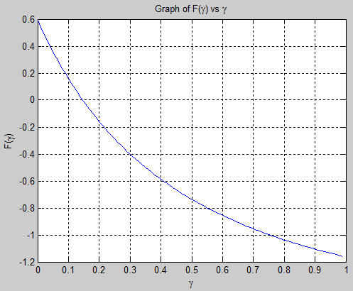
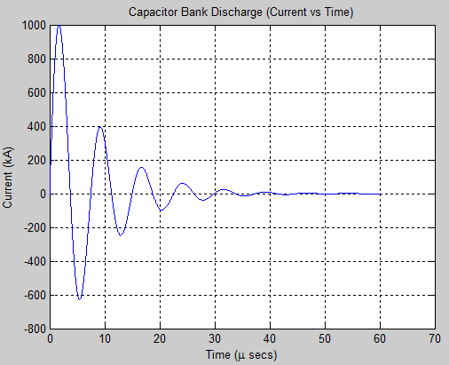
Answers: Accurate inductance (L) = 25.83nH and accurate resistance (R) = 6.4mΩ, estimated inductance (L) = 26.4nH, estimated resistance (R) = 6.5mΩ, inductance error = 2.21% and resistance error = 2.20%.
f)
There are large errors because the inductance and resistance are measured over a greater time period and because multiple peaks are used, the values will be lower than just using the first peak. The inductance changes because of movement of the conductors from electromagnetic forces. The change of inductance increases the total resistance of the circuit.
Question 5
a)
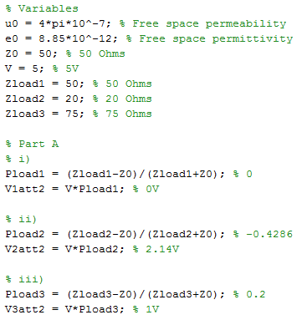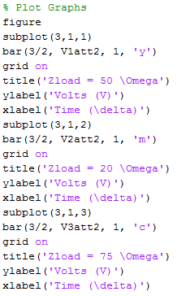
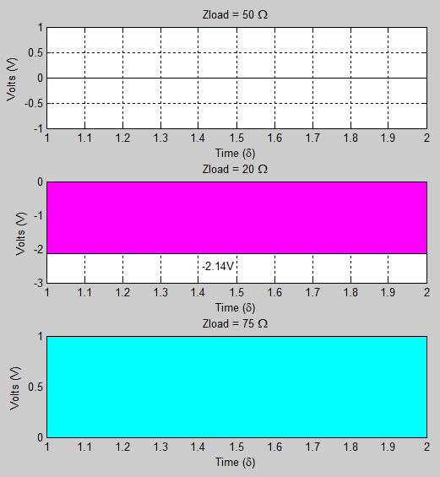
b)
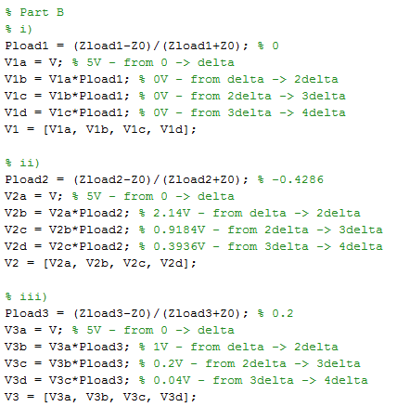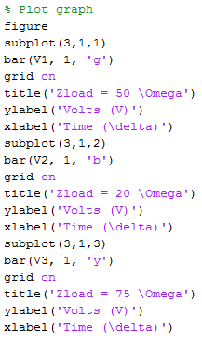
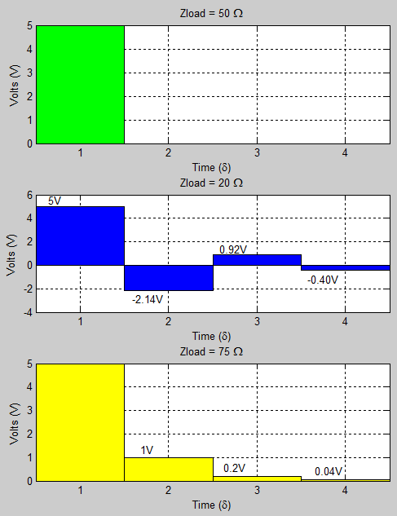
Question 6
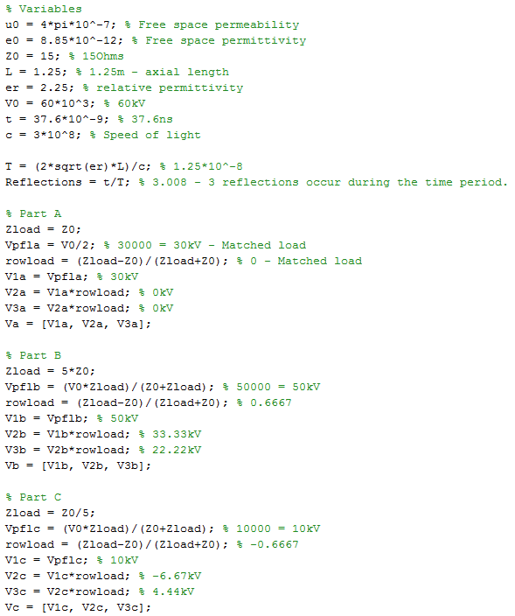
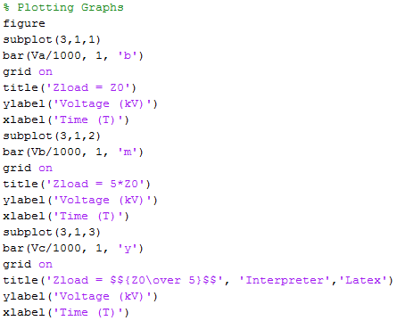
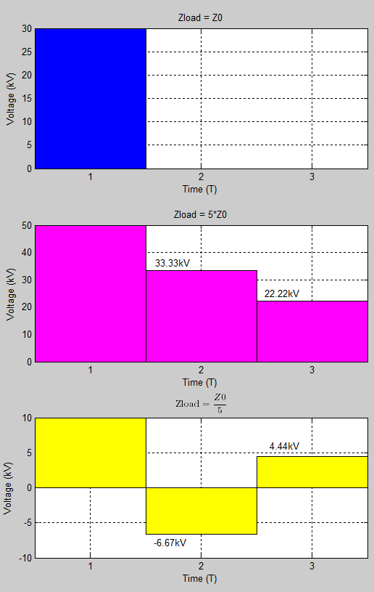
Question 7
i)
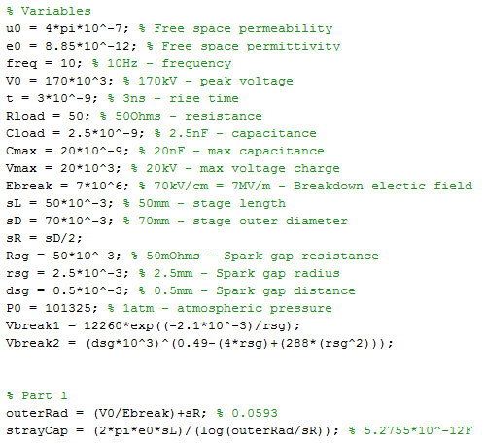
Answer: 5.28pF
ii)
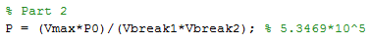
Answer: 53.47MPa
iii)
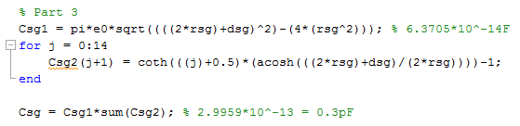
Answer: 0.3pF
iv)
Answer: Voltage loss per stage = (1-0.9463)*100 = 5.37%
v)
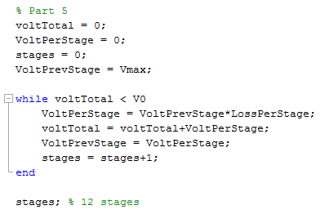
Answer: 12 stages
vi)
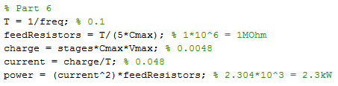
Answer: Charging current = 4.8mA, Feed-forward resistor = 1MΩ, Maximum power = 2.3kW.
vii)
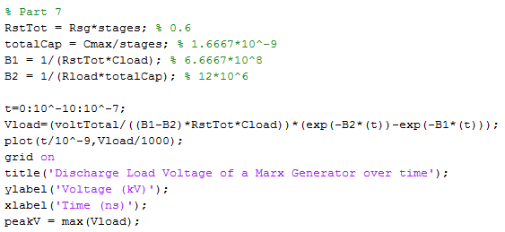
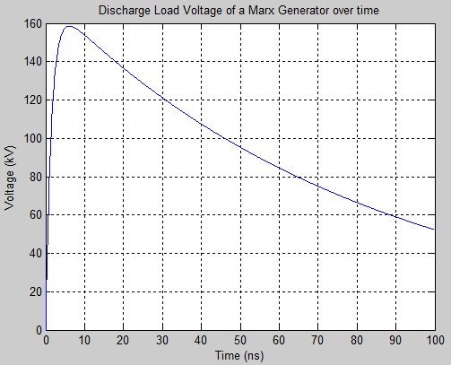
As you can see, the peak voltage does not reach 170kV with 12 stages. Therefore, the number of stages needs to be increased to reach the required voltage.
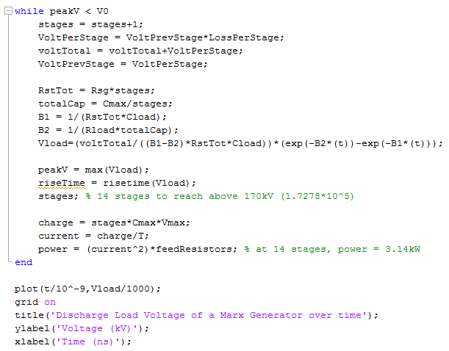
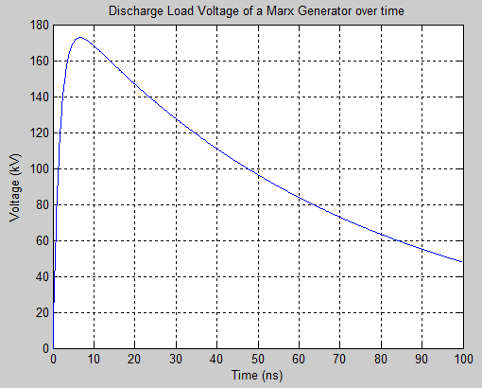
Answer: 14 stages to reach the required voltage. Consequently, the power required is now 3.14kW using a current of 56mA.
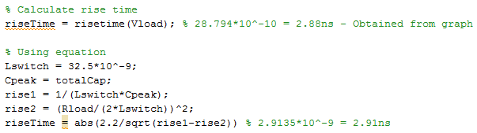
Answer: 2.88ns (from graph) and 2.91ns (from equation).

